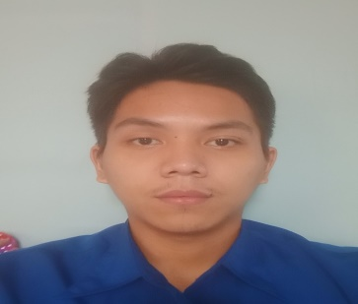**Cedric P. Gurimbao**

**239 Gemini St. Pangarap Village Caloocan City**

**Mobile No: 09958233665**

**Email:** [**cedricgurimbao22@gmail.com**](mailto:cedricgurimbao22@gmail.com)

**Career Objectives**: Secure a responsible career opportunity to fully utilize my training and skills, while making a significant contribution to the success of the company.

**Educational Background**

**Bachelor of Science in Computer Science (Present)**

University of Caloocan City Congress Campus

**Senior High School**

Integrated Innovation and Hospitality Colleges

**Junior High School**

Pangarap High School

**Elementary**

Pangarap Elementary School

**Skills**

HTML

CSS

Javascript

Visual Basic

C

Java

**Seminars Attended/Certificates**

October 22 , 2020 “Introduction to Malware Threats”  
 Presented by **Raphael Centeno**  
 *Trend Micro*

**Scrum Foundation Professional Certificate (SFPC)**

**Personal Information**

Birthplace : Pasig City  
Birthdate : August 11, 2000  
Age : 21  
Height : 5’8½  
Weight : 65 kg  
Nationality : Filipino  
Civil Status : Single   
Language : Filipino, English

**Qualification**

- Excellent written and verbal communication skills.  
- Proficient in Microsoft Office (Word, PowerPoint and Excel)  
- Attended various seminars and trainings for education students

- Can-do attitude with on-time delivery mindset.

-Self-motivated, dedicated, ready to take on new challenges, and work in a fast-paced work environment.

**Projects**

- Barangay ID System using .Net Programming Language and SQL Database

- Car Rental System using .Net Programming Language and Access Database

- Mchotel Website(Static) using HTML, CSS and Javascript. Here’s the link. ([mchotelcdrc.ml](http://mchotelcdrc.ml/))

**Character References**

**Joemen Barrios Jerwin Cabral**CSD Department Coordinator Professor/Instructor  
+639293434038 +639162083302